A Project Based Learning Report on
Market Miner
In partial fulfilment of the requirement For Project Based Learning of BACHELOR OF TECHNOLOGY
In

COMPUTER ENGINEERING
For

Data Warehouse and Mining


BHARATI VIDYAPEETH (DEEMED TO BE UNIVERSITY) COLLEGE OF ENGINEERING, PUNE-43
DEPARTMENT OF COMPUTER ENGINEERING
2026-27

SUBMITTED TO:

Dr. Rohini Khalkar

SUBMITTED BY: | PRN
Veer Jain (29)  Parth Dhoot (19) | 2414110214  2414110203
Bhavyansh Garewal(22) | 2414110206

BHARATI VIDYAPEETH (DEEMED TO BE UNIVERSITY) COLLEGE OF ENGINEERING, PUNE-43 DEPARTMENT OF COMPUTER ENGINEERING

CERTIFICATE

This is to certify that the Project Based Learning report titled “Stock Mining”, submitted by Veer Jain (29), Parth Dhoot (19), Bhavyansh Garewal (22), to the Bharati Vidyapeeth (Deemed to be University), College of Engineering, Pune-43 for the award of the degree of BACHELOR OF TECHNOLOGY in Computer Engineering is a Bonafide record of the PBL work done by them under my supervision.

Place: Pune Dr. Rohini Khalkar
Date:

Acknowledgement

To begin with, we would like to thank our Course Coordinator for providing us this golden opportunity. We are very grateful to our Course Coordinator, Dr. Rohini Khalkar for her valuable support and guidance.
We are also very grateful to all those who helped us in our entire project. We would like to thank Dr. Rohini Khalkar, our Course Coordinator and our HOD Dr. S.B. Vanjale sir for their support and guidance in completing our project-based learning on the topic “Stock Miner”. It was a great learning experience.
I would like to take this opportunity to express my gratitude to all the group members Veer, Parth, Bhavyansh. The project-based learning would not have been successful without their cooperation and inputs. At last, but not the least, we are thankful to our parents and families who encourage us to study and who support us financially and who gave us the opportunity to spend our golden time in learning.
Thanks again to all who helped us.

ABSTRACT

The project “MarketMiner: Stock Trend Clustering and Pattern Mining” focuses on applying Data Warehousing and Data Mining techniques to historical stock market data. The main objective is to organize large volumes of stock data and discover meaningful trends, groups and recurring patterns.
The system collects historical stock information such as opening price, closing price, highest price, lowest price and trading volume. The collected data is cleaned and transformed before being stored in a structured data warehouse.
Data mining techniques are then applied to identify similar stock trends using clustering and discover frequently occurring relationships and patterns using pattern mining. Stocks can be grouped according to their price movement, returns, volatility and trading behaviour.
The project demonstrates important concepts such as data preprocessing, data warehousing, ETL, dimensional modeling, clustering, association/pattern mining and data visualization.
MarketMiner provides a systematic approach for analyzing historical market data and extracting useful knowledge from large datasets. It is intended for academic and analytical purposes and does not provide guaranteed predictions or financial advice.
The proposed system is organised as a pipeline in which each stage prepares the data for the next one. Raw records are first extracted from the data source, cleaned to remove inconsistencies, and transformed into derived measures such as daily return, price change and trend category. The transformed records are then loaded into a data warehouse that follows a dimensional (star schema) design, which keeps the data organised for fast and flexible analytical queries.
Once the data is stored, features that summarise the behaviour of each stock are extracted from the warehouse. These features are normalised and passed to the K-Means clustering algorithm, which divides the stocks into groups with similar return, volatility and trading-volume characteristics. In parallel, continuous values are converted into categories and processed with the Apriori algorithm in order to discover frequent itemsets and association rules, such as the relationship between high trading volume and positive returns.
The results of both techniques are presented through tables and graphical plots, which makes it easier for a reader to interpret the discovered groups and rules. The visual outputs include scatter plots of clusters, cluster-profile charts and rule summaries.
Overall, the report documents the objective, background, tools, implementation, results, advantages and possible applications of MarketMiner. It shows how a combination of data warehousing and data mining can convert large volumes of raw stock records into structured knowledge that supports academic study and analysis.
Keywords: Data Warehousing, Data Mining, ETL, Dimensional Modeling, K-Means Clustering, Apriori, Association Rules, Stock Market Analysis, Data Visualization.

INDEX
Sr. No. | Name of Chapter | Page No.
1 | Introduction | 6–11
2 | Literature Study | 12–17
3 | Hardware & Software Used | 18–22
4 | Explanation of Implemented System | 23–39
5 | Snapshot of Implementation Result | 40–42
6 | Advantages | 43–44
7 | Applications | 45–48
8 | Conclusion | 49–50
9 | Research & References | 51–54

INTRODUCTION

Data Warehousing and Data M ining are important areas of data management and analysis. Data warehousing focuses on collecting and organizing data from different sources into a centralized repository, while data mining focuses on discovering useful patterns and knowledge from large datasets.
The stock market generates a large amount of historical data every trading day. This data contains information such as opening price, closing price, high price, low price and trading volume.
Analyzing this information manually can be difficult because of the size and complexity of the dataset.
Every trading day, a stock exchange records a summary for each listed company. A single record normally contains the opening price, the highest and lowest prices reached during the day, the closing price and the number of shares traded. When such records are collected for hundreds or thousands of companies over several years, the result is a dataset containing hundreds of thousands or even millions of rows. Such a dataset is far too large to be studied by reading it line by line.
Traditional tools such as spreadsheets can display this data and draw simple charts, but they are not designed to organise it permanently, to join it with other descriptive information, or to search it automatically for hidden structure. A data warehouse addresses the first problem by storing the data in a consistent, subject-oriented and time-variant form. Data mining addresses the second problem by applying algorithms that find groups, relationships and recurring patterns without being told in advance exactly what to look for.
The two areas complement each other. The warehouse provides clean, integrated and well-structured input, and the mining algorithms provide the analytical power to learn from that input. MarketMiner has been developed as a practical demonstration of this combination in the subject of Data Warehouse and Mining.
The proposed project, MarketMiner, uses data warehousing and data mining techniques to organize historical stock market information and identify meaningful trends.
The system focuses mainly on:
- Collection of historical stock data
- Data cleaning and preprocessing
- Data warehouse creation
- Stock trend analysis
- Clustering of similar stocks
- Pattern mining
- Visualization of discovered results

Each of the focus areas listed above corresponds to one stage of the project. Collection of historical stock data provides the raw material. Cleaning and preprocessing make the data reliable, because mining algorithms are sensitive to errors, duplicates and missing values. Creation of the data warehouse stores the prepared data in a structure designed for analysis rather than for day-to-day transactions.
Stock trend analysis examines how prices and volumes change over time, for example through daily returns and moving averages. Clustering of similar stocks groups companies whose historical behaviour is alike, and pattern mining looks for combinations of conditions that frequently occur together. Finally, visualization presents the discovered results in graphs and tables so that they can be understood without reading the underlying numbers.
The overall flow of work follows the well-known process of Knowledge Discovery in Databases (KDD), in which raw data is selected, preprocessed, transformed, mined and finally interpreted to obtain useful knowledge. Figure 1 shows these stages.
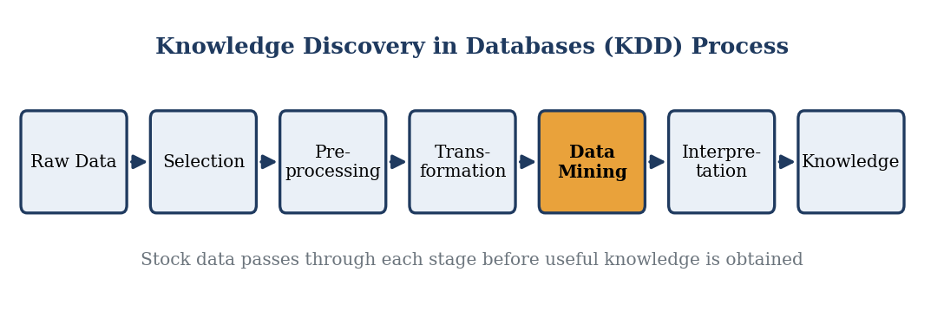
Figure 1: Stages of the Knowledge Discovery in Databases (KDD) process followed by MarketMiner

1.1 Problem Statement
Large volumes of stock market data are generated continuously. Raw stock data by itself does not directly provide meaningful information about relationships between different stocks or recurring market behaviour.
A single price series, such as the closing prices of one company, is easy to plot. The difficulty begins when many companies must be compared at the same time. Each company has its own price level, its own pattern of ups and downs and its own trading activity, and these characteristics are recorded in different columns and across thousands of dates. Without a systematic method it is hard to say which stocks behave alike, which stocks are unusually unstable, or which conditions tend to occur together.
Another difficulty is the quality of the data. Raw files may contain duplicate rows, missing prices, inconsistent date formats and values on very different scales. If such data is given directly to a mining algorithm, the result may be misleading. Volume, for example, is measured in millions of shares while daily return is a small fraction, so an algorithm that uses distance would be dominated by volume unless the values are scaled first.
There is therefore a need for a system that can:
- Store historical stock information systematically
- Clean and transform raw data
- Group stocks with similar behaviour
- Discover frequently occurring patterns
- Present mining results in an understandable form
In other words, the problem is not the lack of data but the lack of an organised and automated way to turn the data into knowledge. The system must first create a trustworthy, structured store of the data. It must then provide analytical methods that are suitable for the nature of the data, namely clustering for grouping similar stocks and pattern mining for finding co-occurring conditions.
The system should also be repeatable. When new stocks or newer dates are added, the same steps should be executed again without manual rework. For this reason the solution is divided into well-defined stages (extraction, cleaning, transformation, loading, feature extraction, mining and visualization), each of which can be run and checked independently.
Finally, the output has to be understandable. A list of cluster numbers or itemsets is of little value to a student or analyst unless it is accompanied by labels, summaries and charts that explain what each group or rule means.

1.2 Scope of the Project
MarketMiner is designed as an academic data mining system for historical stock analysis.
The scope has been kept deliberately focused so that every part of the project can be explained and demonstrated. The data used is historical end-of-day data, the analytical techniques are standard and well documented, and the tools are freely available.
The project can be used to:
- Analyze historical stock prices
- Compare stock performance
- Group similar stocks
- Identify recurring combinations of market behaviour
- Study relationships between stock characteristics
- Demonstrate practical implementation of data mining algorithms
The project focuses on historical analysis rather than guaranteed future stock-price prediction.
Within this scope the project covers data collection, cleaning, warehouse design, feature extraction, K-Means clustering, Apriori pattern mining and visualization. It does not attempt to operate on live market feeds, to place trades, or to claim that the discovered groups and rules will continue to hold in the future.
The scope also sets some practical limits. The quality of the results depends on the quality and length of the historical data that is supplied. Clusters depend on the features that are chosen and on the number of clusters requested, and the patterns depend on the thresholds used for support and confidence. These choices are explained in the implementation chapter so that the results can be reproduced and, if required, tuned.
Because the work is academic, the emphasis is on understanding and demonstrating the techniques of Data Warehousing and Data Mining. The project is therefore suitable as a learning model that can later be extended with larger datasets, additional algorithms and more advanced interfaces.

LITERATURE STUDY

Data Mining is the process of discovering useful patterns and knowledge from large datasets.
In MarketMiner, data mining is used to identify similarities and recurring behaviour in stock data.
The idea of extracting knowledge from data became important as organisations started to store large amounts of electronic records. Data mining draws on statistics, machine learning, database systems and pattern recognition. It is usually described as one step in the broader KDD process, in which the selected data is cleaned, transformed, mined and the mined output is evaluated before it is accepted as knowledge.
Data mining tasks are commonly divided into descriptive tasks and predictive tasks. Descriptive tasks, such as clustering and association rule mining, summarise the general properties of the data. Predictive tasks, such as classification and regression, use known data to estimate unknown or future values. MarketMiner is mainly descriptive, with a classification-style labelling of trends.
Important techniques include:
- Data Preprocessing
Removing missing, duplicate or inconsistent records and converting data into a suitable format.
Real-world data is rarely ready for mining. Preprocessing generally includes data cleaning, data integration, data transformation and data reduction. Cleaning handles missing and noisy values. Integration merges data from several sources. Transformation converts data into forms suitable for mining, such as scaling numeric values or deriving new attributes. Reduction decreases the volume of data while preserving its analytical value.
Stock data has its own preprocessing issues. Markets are closed on weekends and holidays, so dates are not continuous. Corporate actions such as stock splits can cause sudden changes in price that do not represent real performance. Volumes may be zero for illiquid stocks. Such issues have to be recognised and handled before features are calculated.
- Clustering
Grouping stocks that have similar characteristics.
Because clustering is unsupervised, no labels are required. The algorithm decides group membership by measuring how close or far objects are from each other, usually with Euclidean distance. A good clustering has high similarity inside each group and low similarity between different groups.
There are several families of clustering methods. Partitioning methods, such as K-Means, divide the data into a chosen number of groups. Hierarchical methods build a tree of nested clusters. Density-based methods, such as DBSCAN, find regions where points are packed closely together. K-Means is selected for this project because it is simple, fast, easy to explain and works well on numeric features.
- Pattern Mining
Finding frequently occurring relationships or combinations within the processed stock data.
Pattern mining originated from market-basket analysis, where the aim was to find products that customers often buy together. The same idea can be applied to stock data by treating each trading day (or each stock-period) as a transaction and each observed condition, such as High Volume or Positive Return, as an item.
A set of items that appears together in many transactions is called a frequent itemset. From frequent itemsets, association rules of the form A → B can be generated, which state that when condition A occurs, condition B often occurs as well.
- Classification
Stock records may also be categorized into groups such as upward trend, downward trend or stable movement based on predefined conditions.
Classification assigns each record to one of a set of predefined classes. In MarketMiner, a simple rule-based classification is used to label every trading day as upward, downward or stable according to the size of the daily return. These labels are later used as items in pattern mining and help to describe the behaviour of each cluster.
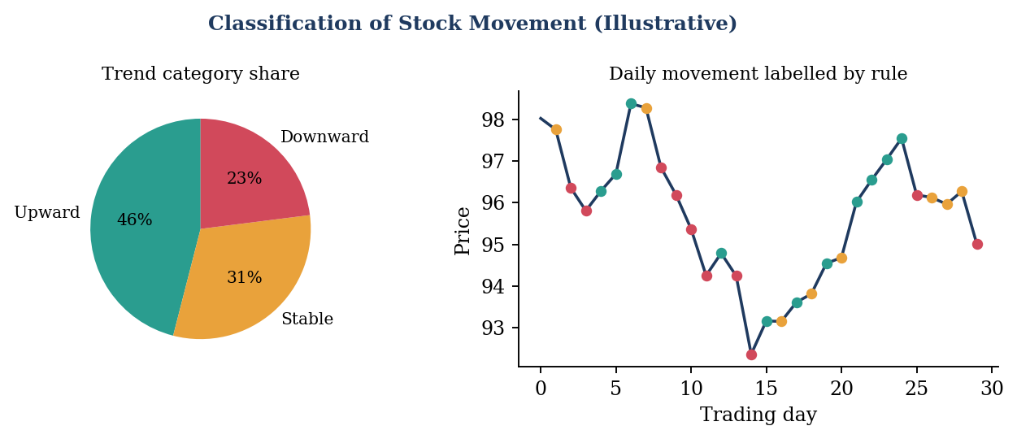
Figure 2: Rule-based classification of stock movement into upward, stable and downward trend (illustrative)
These techniques allow raw stock data to be converted into meaningful analytical information.
Taken together, these techniques form a complete analytical chain. Preprocessing improves the quality of the data, clustering reveals the structure between stocks, pattern mining reveals the relationships between conditions, and classification-style labelling gives the results a readable meaning.

2.1 Clustering and Pattern Mining –

- Stock Trend Clustering
Clustering is an unsupervised data mining technique in which similar data objects are grouped together.
The quality of a clustering is influenced by the features that are used to describe each object. If the features are chosen well, stocks that behave similarly will lie close to each other in the feature space, and the algorithm will be able to separate them into meaningful groups. If the features are poorly chosen or badly scaled, the groups may not reflect real behaviour.
For MarketMiner, stocks can be represented using features such as:
Average return
Price change
Volatility
Trading volume
Moving trend characteristics
Average return is the mean of the daily percentage changes in closing price and indicates how fast a stock has grown on average. Price change measures the overall movement between the first and last day of the study period. Volatility is the standard deviation of daily returns and indicates how widely the returns fluctuate. Trading volume reflects investor activity and liquidity. Moving trend characteristics, such as the difference between a short-term and a long-term moving average, describe the direction in which the price has been drifting.
A clustering algorithm such as K-Means can then divide stocks into groups based on similarity.
Example:
Cluster 1 → High-growth stocks
Cluster 2 → Stable stocks
Cluster 3 → High-volatility stocks
In this example, Cluster 1 collects stocks with a high average return, Cluster 2 collects stocks whose prices move slowly and steadily, and Cluster 3 collects stocks whose prices swing widely. These descriptive names are assigned only after examining the average feature values of each cluster; the algorithm itself only produces cluster numbers.
K-Means works by choosing K initial centroids, assigning every object to its nearest centroid, recalculating each centroid as the mean of its members, and repeating the last two steps until the assignments no longer change. Figure 3 illustrates this iterative process.
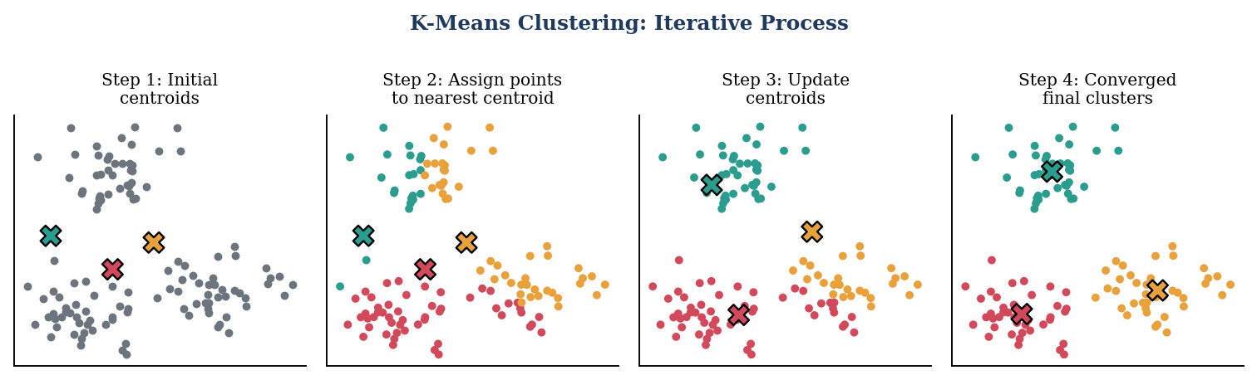
Figure 3: Iterative working of the K-Means clustering algorithm (illustrative)

- Pattern Mining
Pattern mining identifies frequently occurring combinations or relationships in data.
Pattern mining requires the data to be in a transactional form. Each transaction contains the items that were observed together, for example {High Volume, Positive Return, High Volatility}. Numeric attributes must therefore be converted into categories before the algorithm can be applied, a step known as discretisation.
For example, historical data may be transformed into categories such as:
High Volume + Positive Return → Upward Movement
Algorithms such as Apriori can be used to identify frequent itemsets and association rules.
Three measures are used to judge the strength of a rule. Support is the fraction of all transactions that contain both sides of the rule and shows how common the pattern is. Confidence is the fraction of the transactions containing the left side that also contain the right side and shows how reliable the rule is. Lift is the confidence divided by the support of the right side; a lift greater than 1 means that the two sides occur together more often than would be expected by chance.
The Apriori algorithm is based on the property that every subset of a frequent itemset must also be frequent. This property allows the algorithm to discard large numbers of candidate itemsets early, which makes the search practical for datasets of realistic size.

HARDWARE & SOFTWARE USED

3.1 Hardware Used –

The development of MarketMiner requires a computer system capable of handling data processing, database operations and mining algorithms.
Hardware Component | Description
Processor | Multi-core Intel/AMD processor
RAM | 8 GB or more
Storage | SSD/HDD for datasets and project files
Graphics | Integrated or dedicated graphics
Display | Full HD display
Keyboard | Used for entering commands
Mouse | Used for navigation and development

Higher RAM and processor performance can improve the speed of processing larger datasets.
Each component in the table has a specific role in the project. A multi-core processor allows the data processing and the iterative calculations of K-Means to be completed in reasonable time. A minimum of 8 GB of RAM is recommended because Pandas loads datasets into memory and several intermediate tables are created during cleaning and feature extraction.
Storage is needed for the raw datasets, the database files of the data warehouse, the project source files and the generated charts. A solid-state drive gives faster reading and writing, which is helpful when large files are loaded repeatedly. Graphics hardware is not essential because the algorithms used in this project run on the processor, but a display with good resolution makes it easier to examine tables and plots.
The keyboard and mouse are the input devices used to write code, run the notebooks and navigate the development tools. The arrangement of these components is shown in Figure 4.
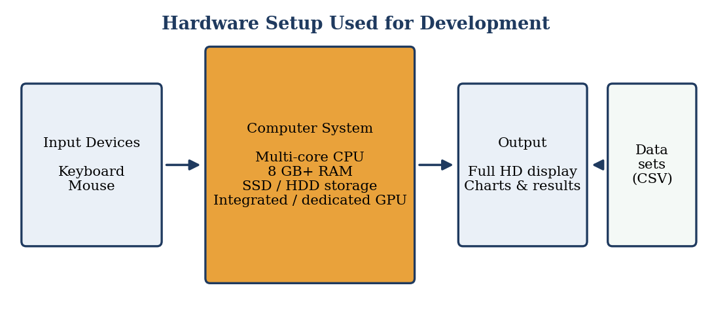
Figure 4: Hardware setup used for the development of MarketMiner

3.2 Software Used -

- Python
Python is used as the primary programming language for data preprocessing, mining and analysis.
Python is widely used in data science because it is easy to read, runs on all common operating systems and has a very large collection of libraries for numerical computing, machine learning and visualization. Using a single language for every stage of MarketMiner keeps the code consistent and makes it simpler to connect the stages to one another.
- Pandas
Used for:
- Loading datasets
- Cleaning data
- Data transformation
- Data analysis
Pandas provides the DataFrame, a table-like structure that is very convenient for stock data. With a few statements it is possible to read a CSV file, sort records by date, remove duplicates, fill missing values, group by stock symbol and calculate rolling averages and returns. In MarketMiner, Pandas is the main tool of the extraction and transformation stages.
- NumPy
Used for numerical calculations and mathematical operations.
NumPy supplies fast array operations on which most other scientific libraries are built. It is used for mathematical calculations such as means, standard deviations, logarithms and percentage changes, and it makes these operations efficient even for large numbers of records.
- Scikit-learn
Used for implementing machine-learning and clustering algorithms such as K-Means.
Scikit-learn offers a consistent interface for many machine-learning algorithms. In this project it provides the K-Means implementation, the StandardScaler for normalising features, and evaluation tools such as the silhouette score. The same library also contains other clustering and classification algorithms that can be tried in future work.
- MLxtend / Pattern Mining Library
Can be used for implementing algorithms such as Apriori and generating association rules.
MLxtend (Machine Learning Extensions) contains ready-to-use functions for the Apriori algorithm and for generating association rules from frequent itemsets. The functions accept a one-hot encoded transaction table and return itemsets with their support values and rules with support, confidence and lift.
- MySQL / PostgreSQL
Can be used to store structured stock information and implement the data warehouse.
A relational database management system is used to hold the data warehouse. Both MySQL and PostgreSQL support the creation of dimension and fact tables, primary and foreign keys, indexes and SQL queries with joins and aggregation, which are the basic needs of a star schema design. Either one can be selected according to what is available to the developer.
- Matplotlib / Seaborn
Used for graphical representation of stock trends and mining results.
Matplotlib is the basic plotting library of Python and is used to create line charts, bar charts and scatter plots. Seaborn is built on top of Matplotlib and gives attractive statistical plots, such as heatmaps, with less code. Together they produce the cluster plots, the correlation matrix and the rule summaries.
- Jupyter Notebook / VS Code
Used as the development environment.
Jupyter Notebook allows code, output and explanations to be kept in a single document, which is very suitable for experiments and for showing results step by step. VS Code is a lightweight editor with debugging, extensions and integrated terminal support, and it is useful for organising the project into modules. The way in which these tools are layered is shown in Figure 5.
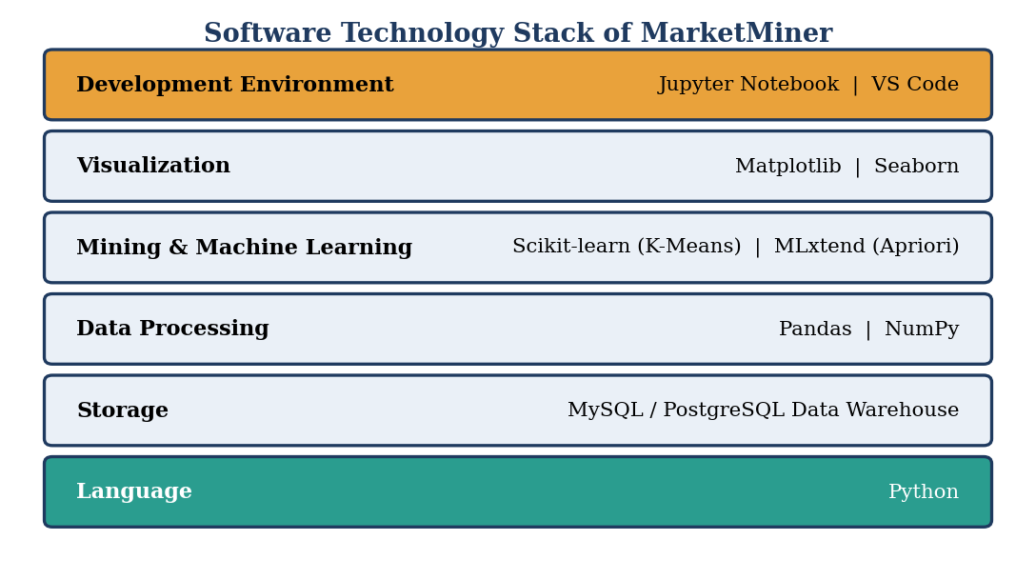
Figure 5: Software technology stack used in MarketMiner

EXPLANATION OF IMPLEMENTED CODE

4.1 System Architecture –

The MarketMiner system follows a sequence of data processing stages:
Stock Data Source
↓
Data Collection
↓
Data Cleaning
↓
Data Transformation
↓
Data Warehouse
↓
Feature Extraction
↓
Clustering & Pattern Mining
↓
Visualization
↓
Analytical Results
The architecture separates data storage from data mining operations.
The data warehouse acts as the central repository, while the mining layer extracts useful information from the stored data.
The architecture can be viewed as two cooperating layers. The storage layer contains the stages that bring the data in, clean it, transform it and keep it in the warehouse. The mining layer contains the stages that read from the warehouse, extract features, apply clustering and pattern mining and finally present the results.
Separating the layers has practical benefits. The warehouse needs to be built only once and can then be used by many different mining experiments. If a different algorithm is introduced, only the mining layer has to change. If a new data source is added, only the extraction and transformation stages have to change. This modular design also makes the system easier to test, because the output of each stage can be inspected before the next stage is run.
Figure 6 shows the complete architecture of MarketMiner, with the storage layer and the mining layer marked.
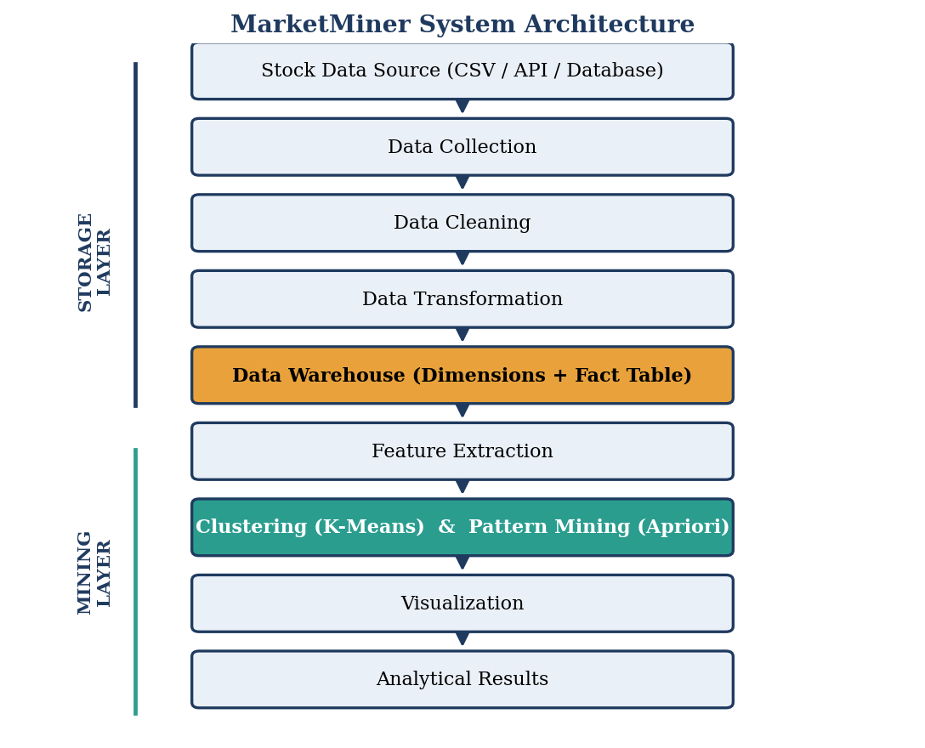
Figure 6: System architecture of MarketMiner showing the storage layer and mining layer

4.2 ETL and Data Warehouse Implementation

The ETL process consists of three major stages:
ETL stands for Extract, Transform and Load. It is the standard method by which data from different sources is made ready for a data warehouse. Extraction reads the data, transformation corrects and enriches it, and loading writes it into the warehouse tables. The flow of data through these stages is shown in Figure 7.
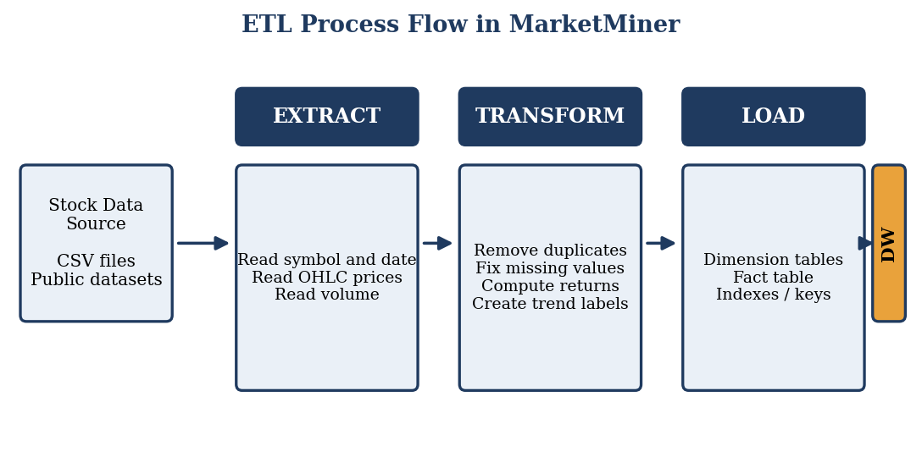
Figure 7: ETL process flow from the stock data source to the data warehouse

1. Extract
Historical stock information is collected from the selected dataset/source.
The source can be a set of CSV files downloaded from a public repository, a collection of files exported from a financial website, or a database table. Whatever the source, the extraction step reads each file into a table in memory and checks that the expected columns are present. Files that have missing columns or an unreadable format are reported rather than silently ignored.
During extraction, a stock symbol is attached to each record if the file does not already contain one, so that data from many companies can be combined into a single table without confusion.
Data may include:
- Stock symbol
- Date
- Open
- High
- Low
- Close
- Volume
Open is the price of the first trade of the day, Close is the price of the last trade, High and Low are the maximum and minimum prices reached during the day, and Volume is the number of shares traded. Together they are often called OHLCV data. Figure 8 displays a sample of such data as a candlestick chart with trading volume, together with a short moving average that smooths the daily fluctuations.
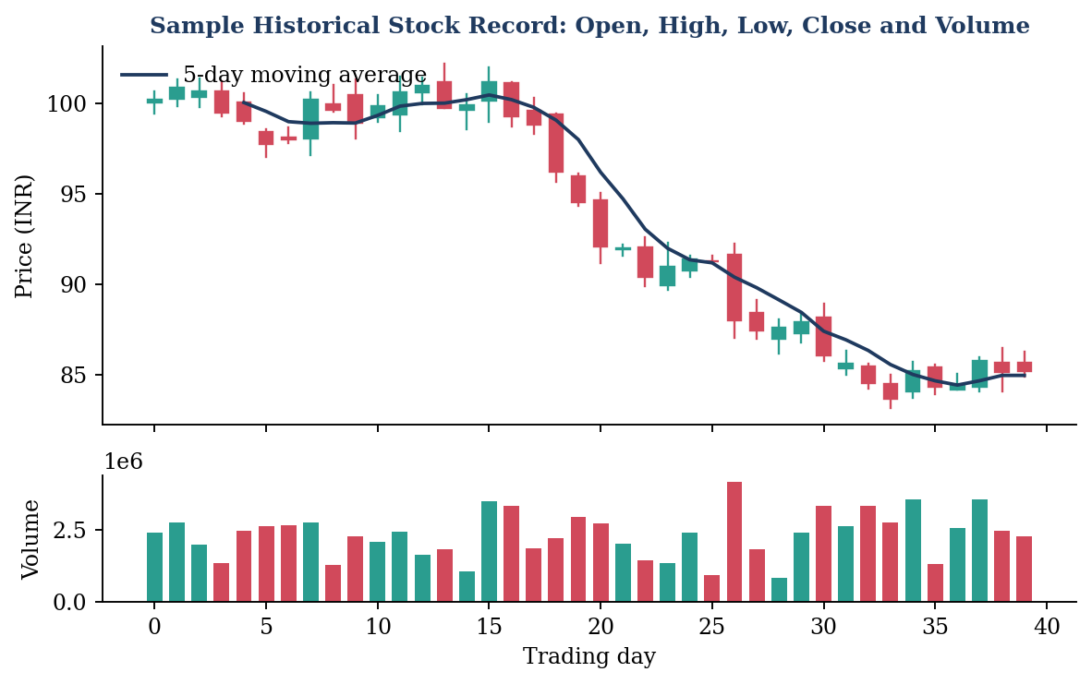
Figure 8: Sample OHLCV stock data shown as a candlestick chart with volume and moving average (illustrative)

2. Transform
The collected data is processed by:
- Removing duplicate records
- Handling missing values
- Converting dates
- Standardizing numerical values
- Calculating returns
- Calculating price changes
- Creating trend categories
Duplicate records arise when the same file is loaded twice or when the source repeats rows. They are identified using the combination of stock symbol and date, and only one record is retained. Missing values are handled according to their nature: a short gap in price can be filled using the previous day's value or by interpolation, while a record in which most fields are absent is removed.
Dates are converted into a single standard date type so that they can be sorted correctly and so that day, month, quarter and year can be extracted for the date dimension. Numerical values are converted to the correct numeric types and standardised in format, for example by removing thousand separators and currency symbols.
Two important derived measures are calculated. The daily return is the relative change in closing price from the previous day: Return = (Close today − Close yesterday) / Close yesterday. The price change is the difference between closing and opening price on the same day: Price Change = Close − Open. These measures describe the movement of a stock independently of its price level and are therefore suitable for comparison between different stocks.
Trend categories are created with simple threshold rules. For instance, a day with return above a positive threshold can be labelled Upward, a day with return below a negative threshold can be labelled Downward, and the remaining days can be labelled Stable. The thresholds are parameters and can be changed to make the labels more or less sensitive. Figure 9 shows the effect of cleaning on a sample dataset.
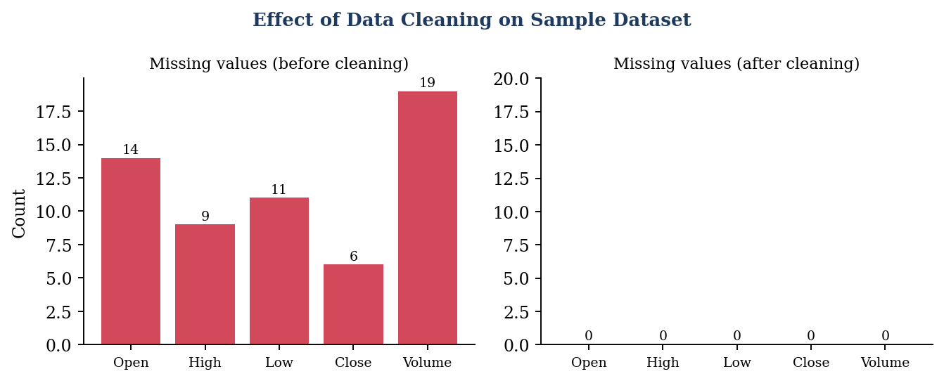
Figure 9: Missing values in a sample dataset before and after the cleaning step (illustrative)

3. Load
The processed data is loaded into the data warehouse.
Loading is carried out in a fixed order. The dimension tables are filled first so that every stock and every date has a unique identifier. The fact table is filled afterwards, using these identifiers as foreign keys. Loading in this order guarantees that no fact record refers to a stock or date that does not exist.
Indexes are created on the key columns to make later queries faster. After loading, simple checks such as counting rows and comparing totals with the source files confirm that no data has been lost.
A possible warehouse structure can contain:
Stock Dimension
- Stock ID
- Stock Symbol
- Company Name
- Sector
Date Dimension
- Date ID
- Date
- Day
- Month
- Quarter
- Year
Stock Fact Table
- Stock ID
- Date ID
- Open Price
- High Price
- Low Price
- Close Price
- Volume
- Return
- Price Change
This design follows the star schema of dimensional modeling. The fact table is at the centre and stores the measurable values of each stock on each date, such as prices, volume, return and price change. The dimension tables surround it and store the descriptive information that is used to filter and group the facts, such as the company name, sector, month, quarter and year.
A star schema is preferred to a fully normalised design for analysis because it needs fewer joins. A question such as the average return of each sector in each quarter can be answered by joining the fact table with just two dimension tables and grouping the result. The schema is also easy to extend: a new descriptive attribute is added to a dimension table without altering the fact table, and a new measure is added to the fact table without altering the dimensions.
The structure of the warehouse used in MarketMiner is shown in Figure 10.
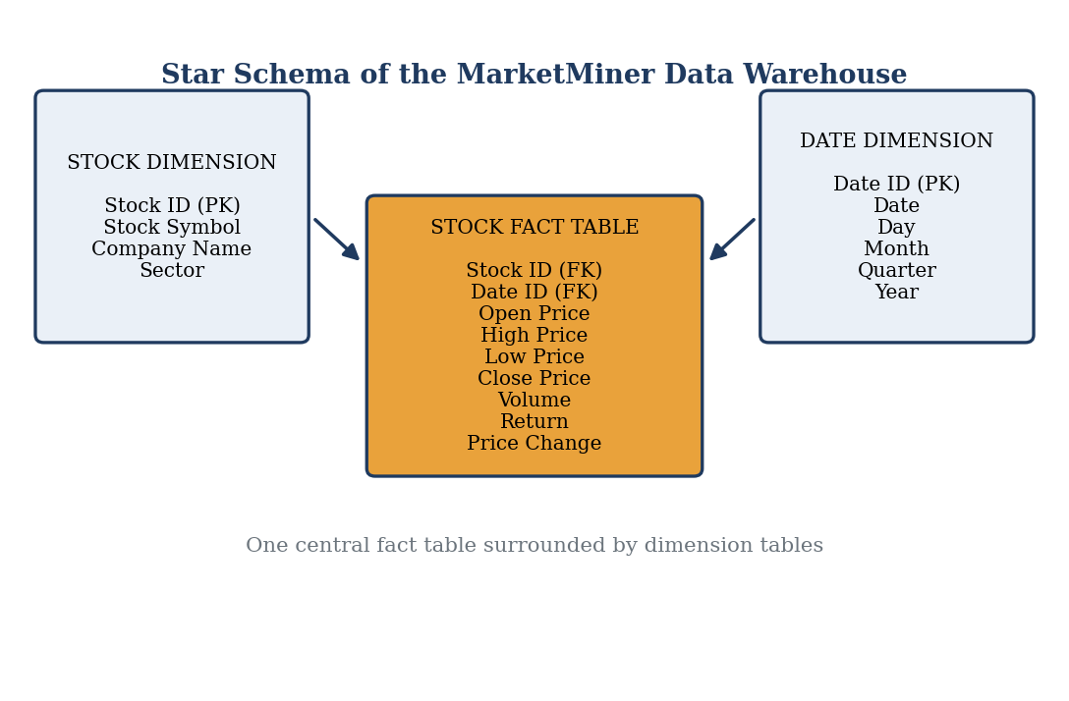
Figure 10: Star schema of the MarketMiner data warehouse

4.3 Stock Trend Clustering
The clustering stage groups stocks according to their historical characteristics.
The input to the clustering stage is not the raw daily data but a compact table in which each row represents one stock. This table is produced by aggregating the fact table with the help of the dimension tables. Working at the stock level allows the algorithm to compare the overall behaviour of companies rather than individual days.
First, relevant features are selected from the warehouse.
Example features:
- Average daily return
- Volatility
- Average trading volume
- Percentage price change
The average daily return is the mean of the daily returns over the study period. The volatility is the standard deviation of the same daily returns. The average trading volume is the mean number of shares traded per day, and the percentage price change compares the final closing price with the first closing price. These four values together describe how much a stock earns, how steady it is and how actively it is traded.
The features are normalized so that one feature does not dominate the clustering process.
Normalisation is necessary because the features are measured on very different scales. Volume may be in millions, whereas return is a fraction of one. A common method is the z-score, in which every value is replaced by (value − mean) / standard deviation, so that each feature has a mean of zero and a standard deviation of one. After this step each feature contributes equally to the distance calculation. The effect is shown in Figure 11.
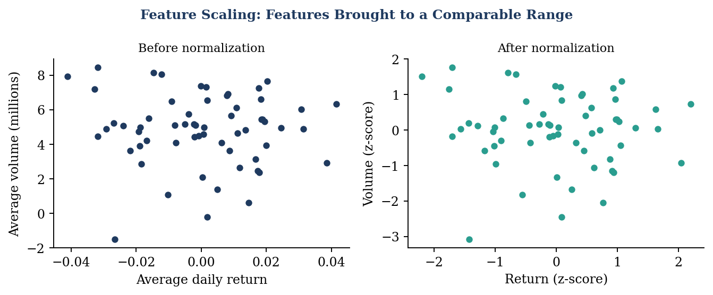
Figure 11: Features before and after normalisation (illustrative)
The K-Means clustering algorithm can then be applied.
K-Means divides n objects into K clusters by minimising the sum of squared distances between each object and the centroid of its cluster. The algorithm is easy to implement and runs quickly even on large datasets. Its main requirements are that the number of clusters be specified in advance and that the features be numeric and scaled.
Basic process:
Input Data → Feature Selection → Normalization → Select K → Initialize Centroids → Assign Clusters → Update Centroids → Repeat → Final Clusters
The process begins with the normalised table of features. K is selected, and K initial centroids are placed, either at random or by a smarter method such as K-Means++. Each stock is assigned to the closest centroid, and each centroid is then moved to the average position of the stocks assigned to it. The assignment and update steps are repeated until the centroids stop moving or a maximum number of iterations is reached.
Since the result depends on the initial centroids, the algorithm is normally run several times with different starting positions and the best result, the one with the smallest total squared distance, is kept.
The choice of K is guided by two commonly used methods. In the elbow method the total within-cluster distance is plotted against K, and the point after which the curve flattens is chosen. In silhouette analysis, the average silhouette score is calculated for each K, and the K with the highest score is preferred, since a high score means that stocks are close to their own cluster and far from the others. Figure 12 shows both methods for an illustrative dataset.
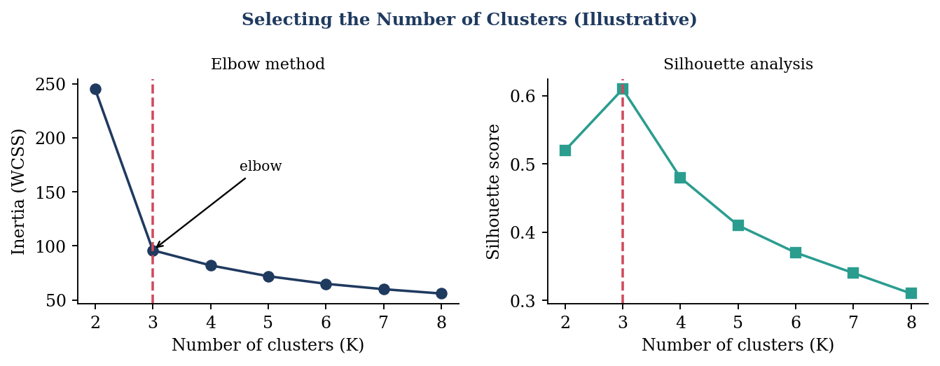
Figure 12: Elbow method and silhouette analysis used to choose the number of clusters (illustrative)
The resulting clusters can help identify groups of stocks with similar historical behaviour.
Once the final clusters are available, each cluster is examined by calculating the average value of every feature over its member stocks. These cluster profiles are used to give each cluster a meaningful name. For example, a cluster with the highest average return can be called high-growth, a cluster with the lowest volatility can be called stable, and a cluster with the highest volatility can be called high-volatility.
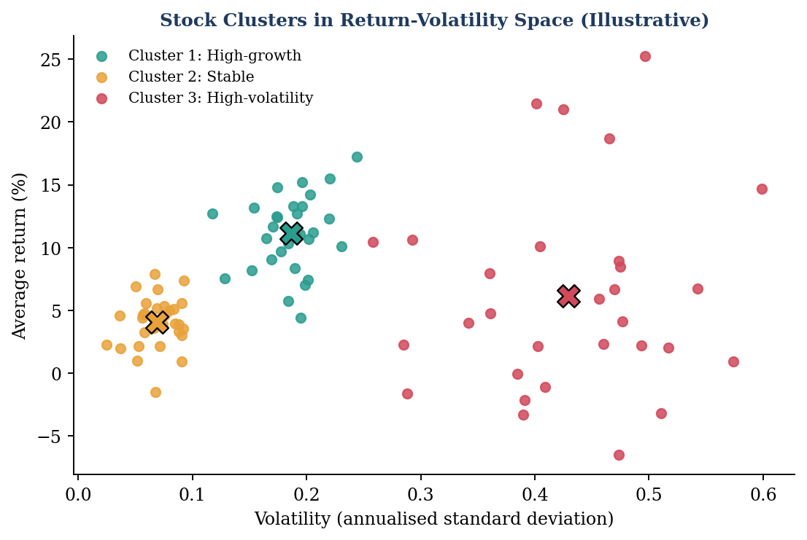
Figure 13: Stocks grouped into three clusters in return-volatility space (illustrative)
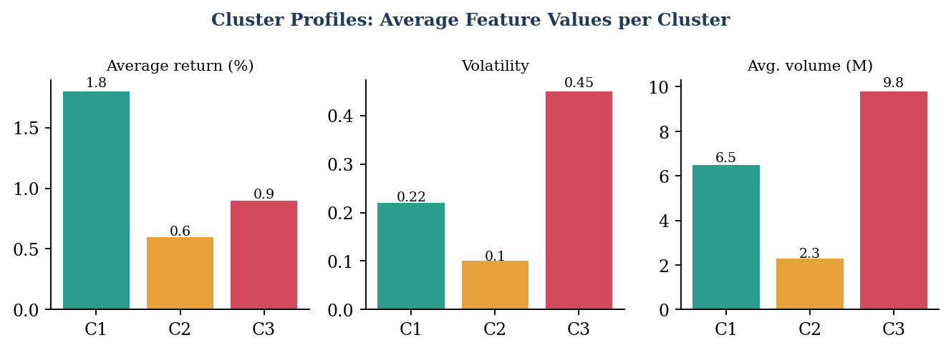
Figure 14: Average feature values of each cluster used to interpret the clusters (illustrative)
The cluster labels can also be stored back in the warehouse as an additional attribute of the stock dimension. This allows later queries to compare, for example, the performance of one cluster with another over any period.

4.4 Pattern Mining Implementation
The pattern mining stage identifies recurring combinations in stock behaviour.
Pattern mining works on transactions. In MarketMiner, every stock-day (or every stock-period) is treated as one transaction, and the conditions that were observed in it are treated as the items of the transaction. The purpose is to find which conditions frequently occur together.
Continuous numerical values can first be converted into categories.
For example:
Feature | Category
Return > threshold | Positive Return
Return < threshold | Negative Return
High volume | High Volume
High price variation | High Volatility
The transformed records can then be processed using Apriori.
For example, one transaction may be {High Volume, Positive Return, High Volatility, Upward Trend}, and another may be {Low Volume, Negative Return, Downward Trend}. The transactions are written in a one-hot table in which each column is an item and each cell is true or false. Such a table is the input format expected by the Apriori implementation.
General process:
Transaction Data → Candidate Itemsets → Support Calculation → Frequent Itemsets → Association Rules → Confidence/Lift Analysis
Candidate itemsets of size one are formed first, and their support is counted. Items whose support is below the minimum threshold are removed. The remaining frequent items are combined to form candidate pairs, the supports of the pairs are counted and infrequent pairs are removed. This process of joining and pruning is repeated for larger itemsets until no new frequent itemset can be found.
From each frequent itemset, rules are generated by splitting the itemset into a left side and a right side. Each rule is evaluated using confidence and lift, and rules below the chosen thresholds are discarded. The rules that remain are the patterns reported by the system. Figure 15 illustrates the working of the algorithm.
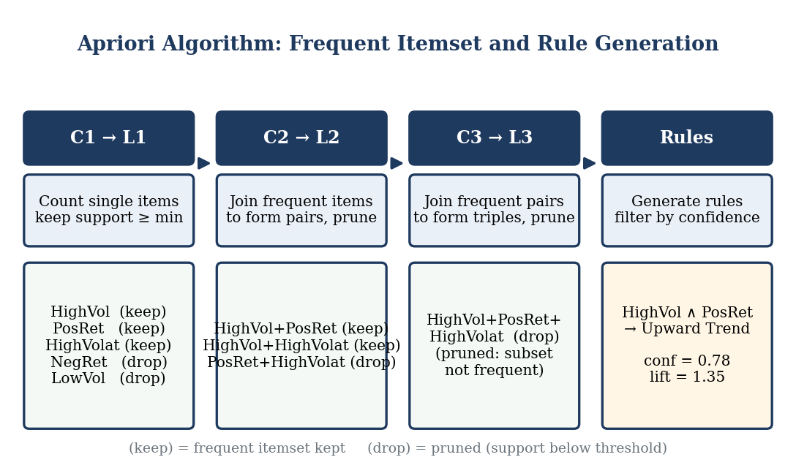
Figure 15: Working of the Apriori algorithm: candidate generation, pruning and rule generation (illustrative)
Example pattern:
High Volume + Positive Return → Upward Trend
This rule means that, in the analysed data, days with high trading volume and positive return were frequently followed by, or accompanied by, an upward trend label. The rule is accepted only if its support and confidence exceed the thresholds and its lift is greater than 1, which indicates a genuine association rather than a coincidence.
Rules are normally compared using a plot of support against confidence, with the lift shown by colour or size. This makes it easy to select the rules that are both common and reliable. Figure 16 shows such a plot.
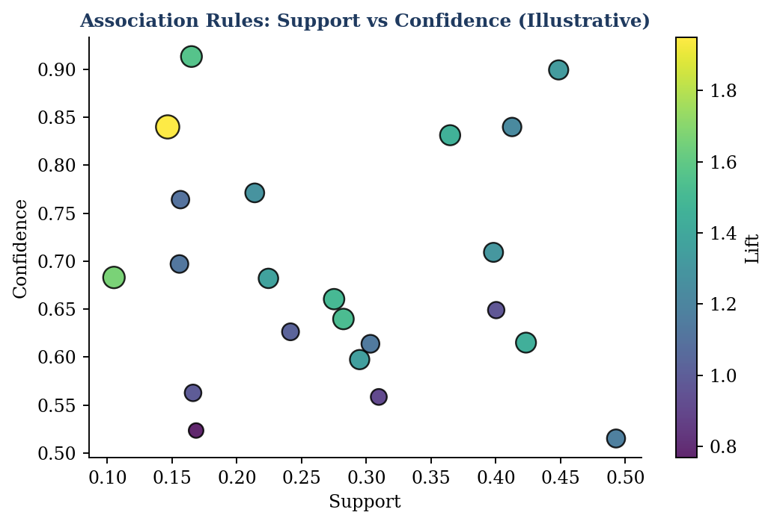
Figure 16: Association rules plotted by support and confidence, with lift shown by colour (illustrative)
The discovered patterns can be displayed through tables or charts for easier interpretation.
Besides tables and charts, correlation heatmaps help to understand which features move together. A strong positive relationship between return and price change, for example, is expected, whereas a strong relationship between volatility and volume may reveal that heavily traded stocks also tend to be more unstable.
It should be remembered that an association rule describes a relationship in past data and does not prove that one condition causes the other. The patterns are therefore used for understanding and exploration rather than as guaranteed signals.

4.5 SNAPSHOTS –

- UI –
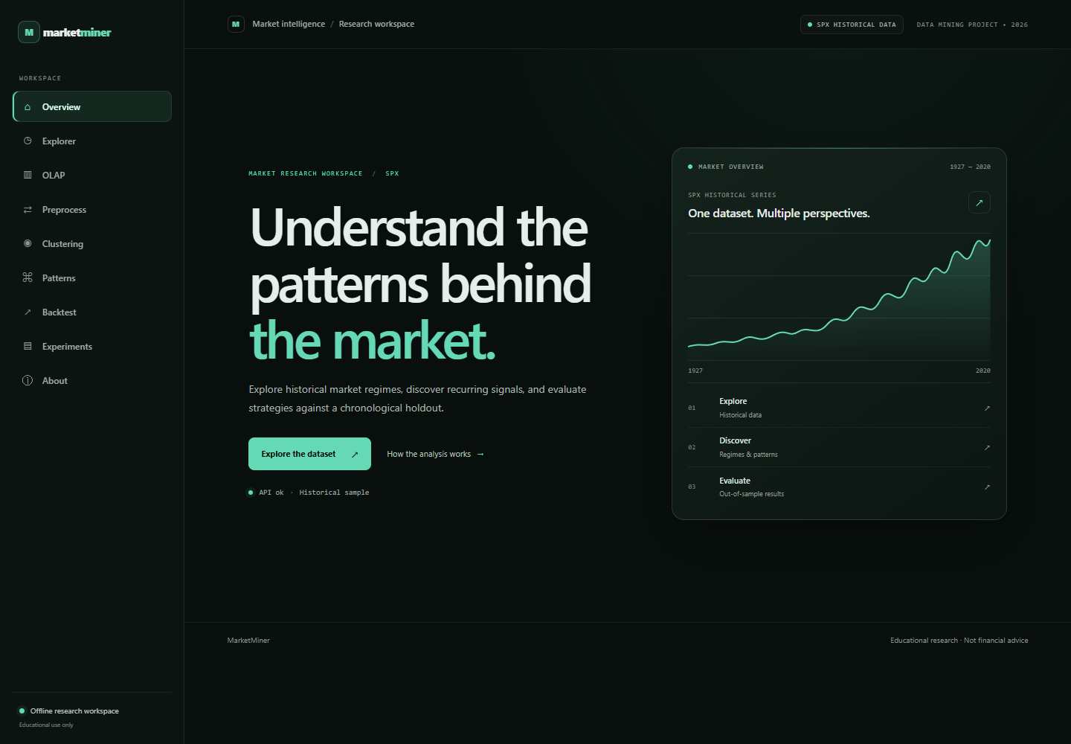
Fig. UI
- OLAP - 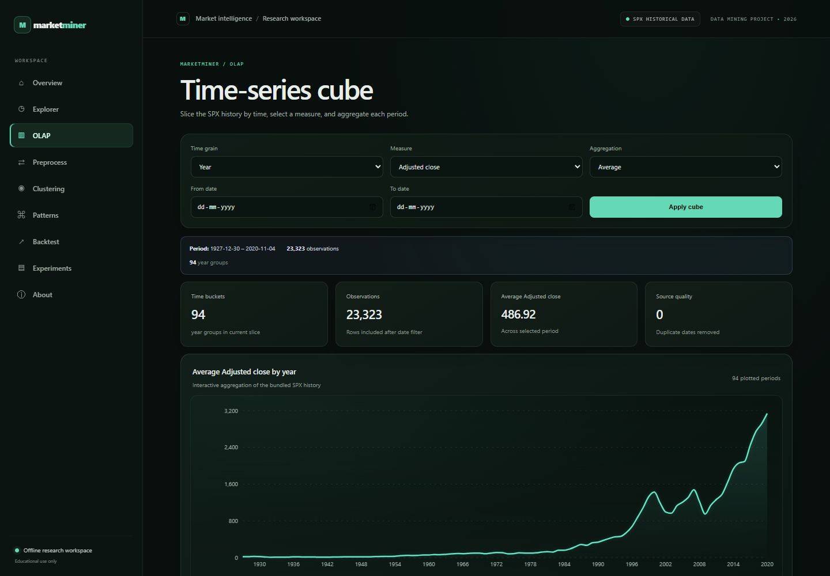
. OLAP page showing its controls and key output.

- Pre-process –
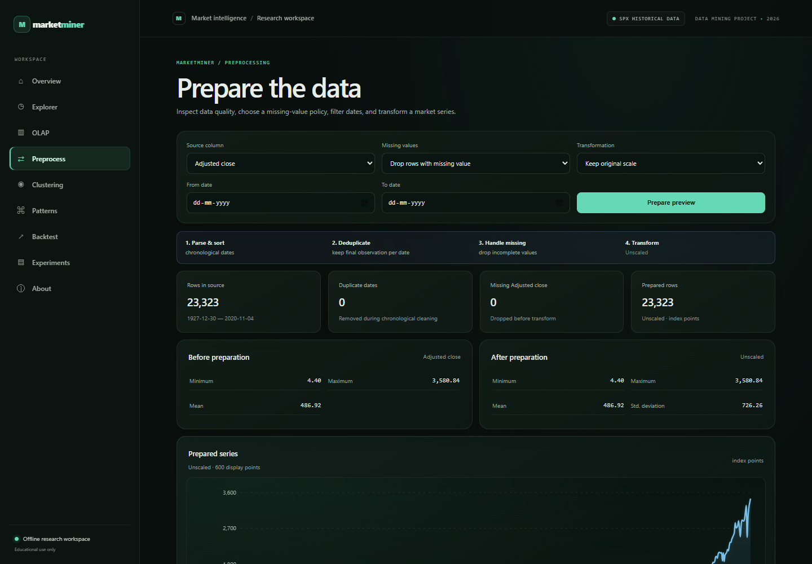
Preprocess page showing its controls and key output.

Clustering - 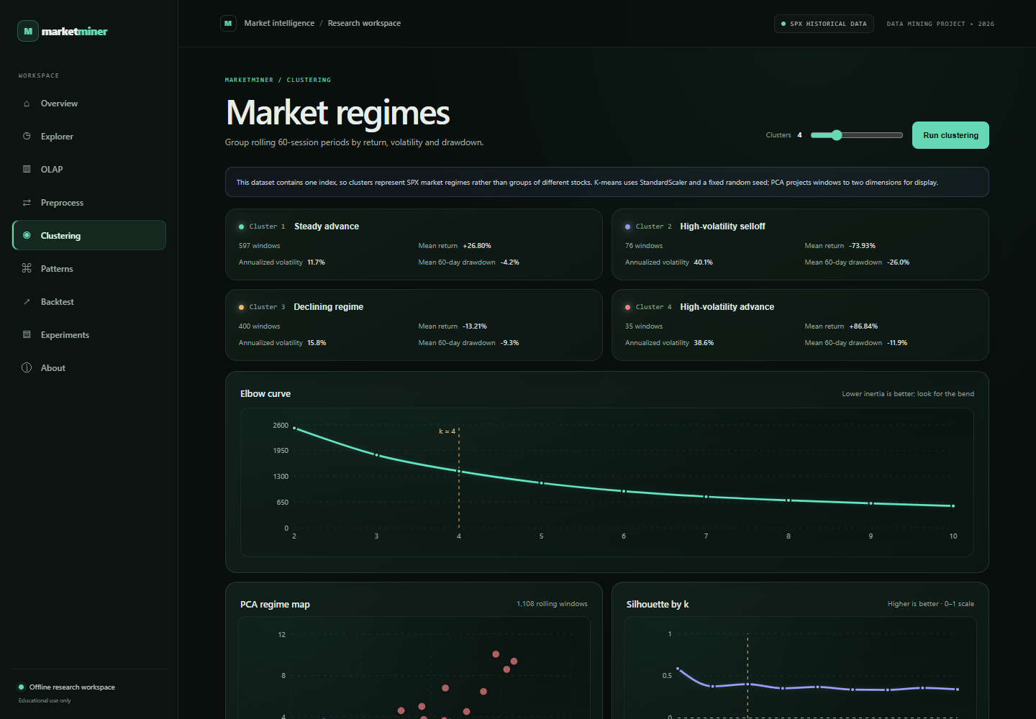

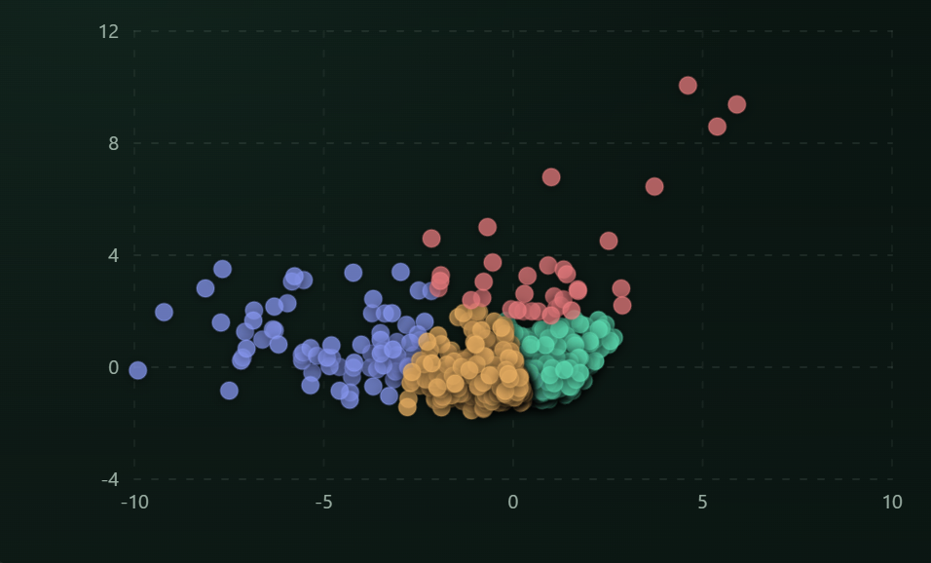PCA regime map. Each point is a rolling window, colored by its assigned regime.

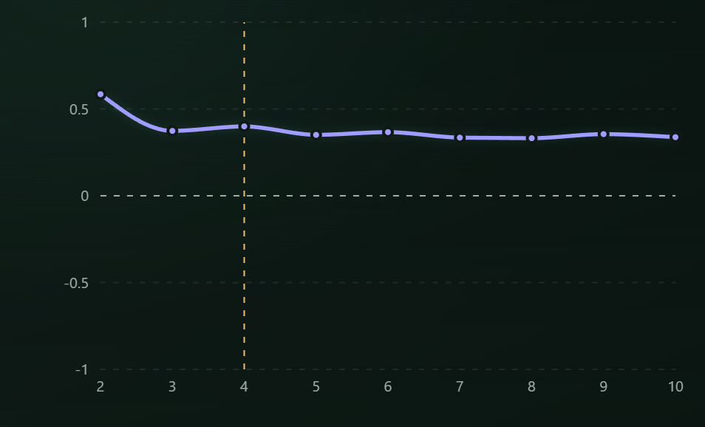

Silhouette score by cluster count. Higher values indicate better separation on this diagnostic scale.

Patterns –
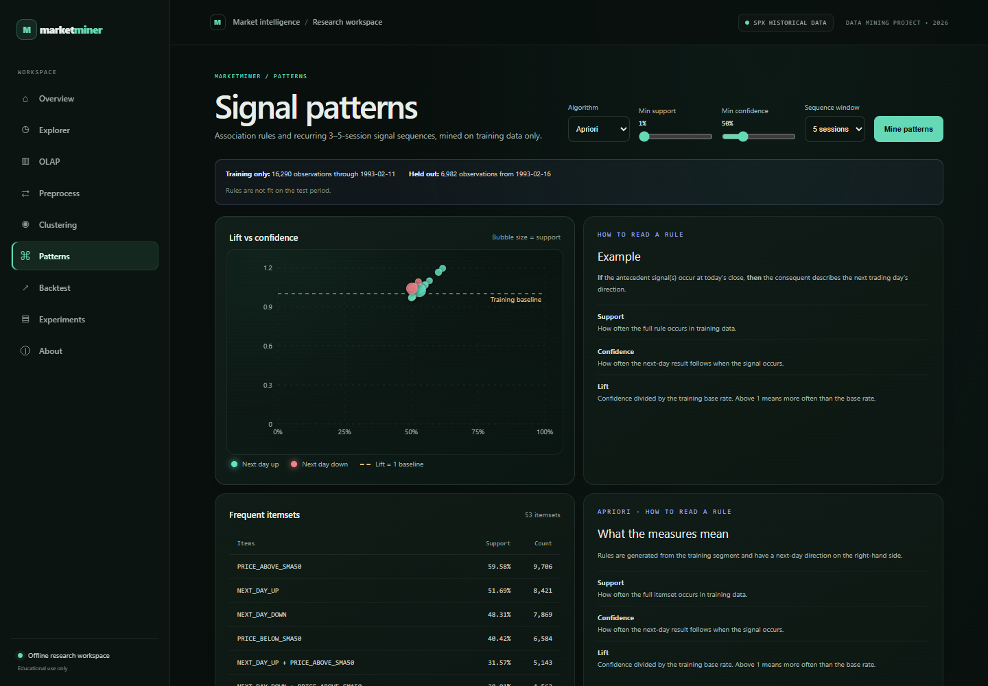
Patterns page showing its controls and key output.

Backtest –
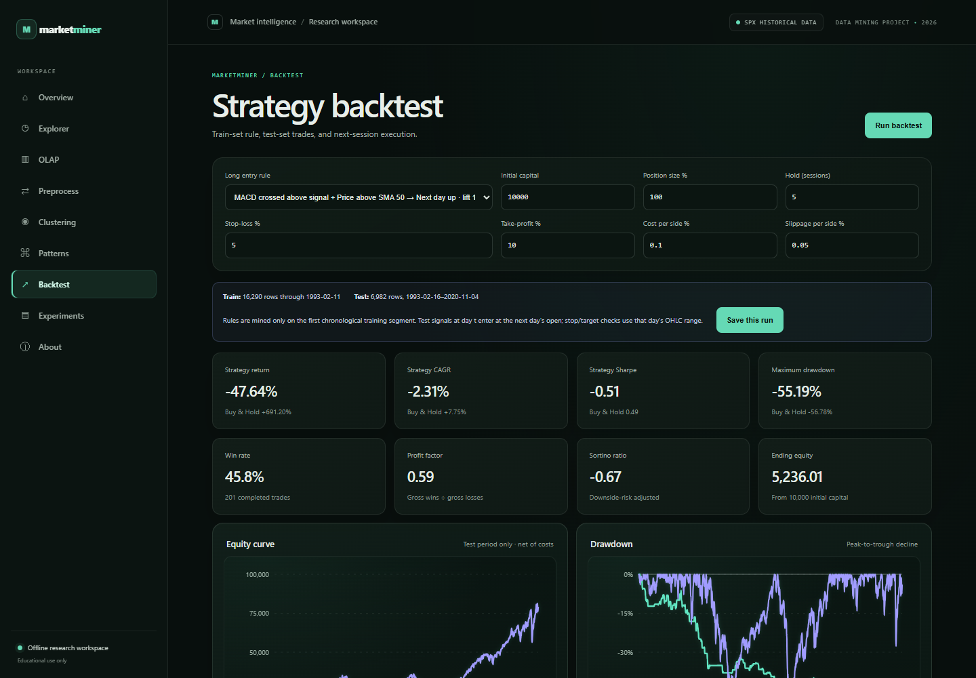
Backtest page showing its controls and key output.

Backtest – Strategy Performance Graph-
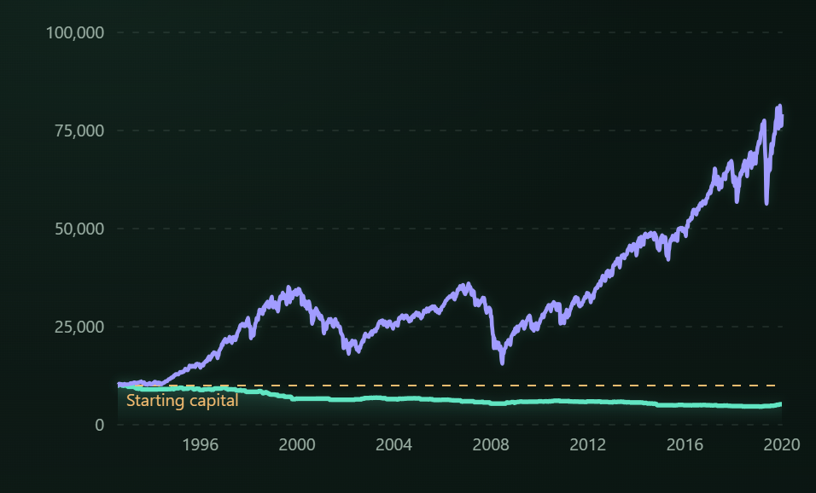

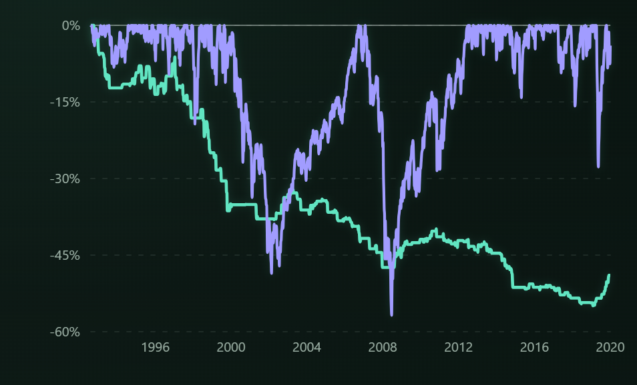

In Addition to the snapshots above, the system produces a set of result visualizations that summarise the outcome of the mining stages. The figures in this section illustrate the form in which these results are presented and are drawn from sample data.

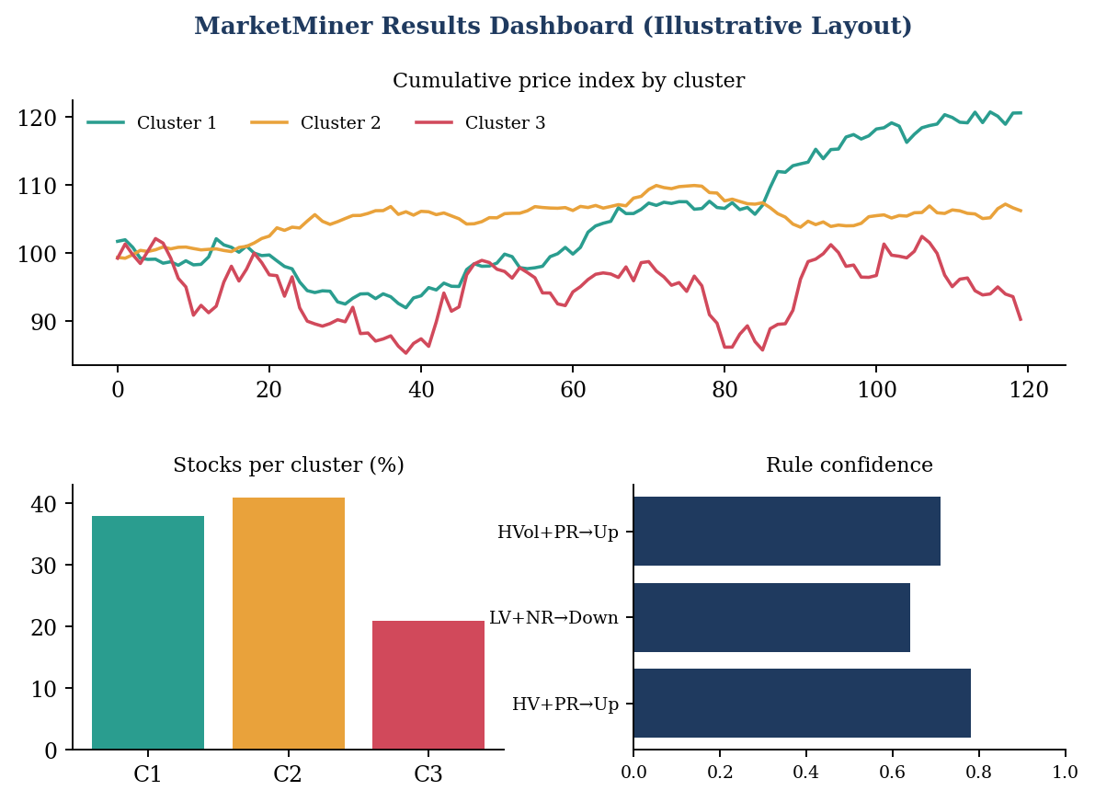
Figure 17: Layout of a results dashboard combining cluster trends, cluster sizes and rule confidence (illustrative)
The upper chart of the dashboard compares the cumulative price index of the stocks of each cluster over time. This shows at a glance that the high-growth cluster rises faster, while the stable cluster moves in a narrow band and the high-volatility cluster fluctuates widely. The lower left chart shows how many stocks belong to each cluster, and the lower right chart lists the confidence of the strongest association rules.
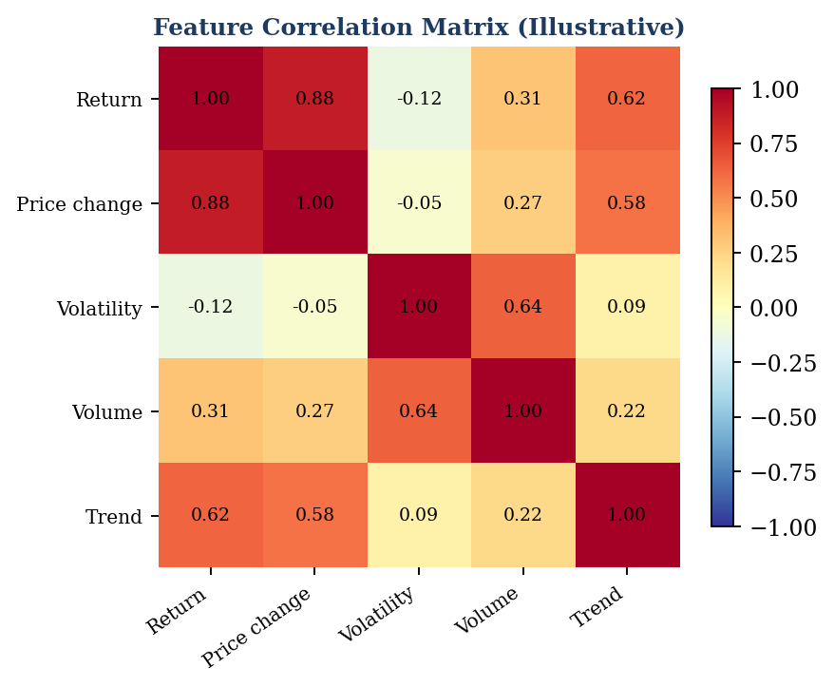
Figure 18: Correlation matrix of the features used in the analysis (illustrative)

The correlation matrix gives a numerical summary of how the features are related. Values close to +1 or −1 indicate a strong relationship, and values close to 0 indicate little linear relationship. Features that are almost perfectly correlated carry similar information, and such a matrix can be used to decide whether one of them can be dropped from the clustering.
Together, these outputs allow a reader to move from the overall picture to the detail: from the number of clusters and their sizes, to the characteristics of each cluster, to the rules that describe frequent combinations of market behaviour.

ADVANTAGES

Advantages -
- Organized Data Storage: Historical stock data can be stored systematically.
A data warehouse keeps all cleaned records in one consistent place with defined keys and a fixed structure. Analysts need not search through many separate files, and the same dataset can be reused for many different analyses.
- Large Dataset Analysis: Mining techniques can process large quantities of historical records.
The algorithms used in the system work on whole tables at once. A task that would take a person many days to carry out by hand, such as comparing the behaviour of hundreds of stocks over several years, can be completed in a short time.
- Trend Identification: Clustering can identify groups of stocks with similar behaviour.
By grouping stocks according to measurable characteristics, clustering reveals structure that is not obvious from individual price charts. Stocks that belong to the same cluster can be studied together, and stocks that fall in different clusters can be compared.
- Pattern Discovery: Frequent patterns can be extracted from historical market data.
Pattern mining reports combinations of conditions that frequently occur together and measures them with support, confidence and lift. The strength of each pattern is therefore expressed as a number and not left to personal opinion.
- Automated Analysis: Repetitive analytical tasks can be performed programmatically.
Once the steps have been written as code, they can be repeated for a new dataset without effort. This saves time, reduces manual mistakes and makes the results reproducible, which is important in academic work.
- Visualization: Results can be represented using graphs and charts.
Charts such as scatter plots, bar charts and heatmaps convert numerical output into pictures that can be understood quickly. They also make it easier to explain the results to people who are not familiar with the algorithms.
- Educational Value: Demonstrates practical Data Warehousing and Data Mining concepts.
The project brings together ETL, dimensional modeling, preprocessing, clustering and association rule mining in a single case study. It therefore helps students to see how the individual topics of the subject are connected in a real workflow.
- Expandable: Additional stocks, features and algorithms can be incorporated.
The design is modular, so new stocks can be added by loading more rows, new features can be added by extending the feature table, and new algorithms can be added to the mining layer without disturbing the warehouse.
Because the tools used are open source, the system can be developed and used without licence cost, which makes it suitable for students and for small research groups.
- APPLICATIONS

MarketMiner can have several academic and analytical applications.
The applications listed below arise from the two capabilities of the system: the ability to organise large amounts of historical data and the ability to discover groups and patterns in it. They are described for academic and analytical use.
- Stock Market Analysis
Used to study historical price movements and trading behaviour.
By examining historical prices, returns and volumes together, an analyst can study how individual stocks and sectors behaved during rising and falling periods. The cluster and pattern results add a further view by showing which stocks behaved alike and which conditions were common during the period under study.
- Portfolio Analysis
Stocks with similar historical characteristics can be identified for further portfolio analysis.
A portfolio that contains only stocks of the same cluster may be less diversified than it appears, because those stocks have behaved in a similar way. By identifying clusters, an analyst can see which stocks are alike and which are different, and can study the effect of mixing stocks from different clusters on the overall variation of returns.
- Market Segmentation
Stocks can be divided into groups based on return, volatility and trading behaviour.
Market segmentation divides a large set of securities into smaller, more homogeneous groups. This simplifies analysis, because each group can be studied with methods suited to its characteristics, and it makes reports more compact because a handful of segments can represent hundreds of stocks.
- Financial Data Research
Researchers can use the system to study historical relationships and patterns.
Researchers and students can use the warehouse and the mining results as a ready dataset for studying relationships such as the link between volume and price movement, or the stability of cluster membership across different time periods. The reproducible pipeline allows others to repeat and verify the experiments.
- Educational Demonstration
The project provides a practical example of:
- Data Warehousing
- ETL
- Data Preprocessing
- K-Means Clustering
- Apriori Pattern Mining
- Data Visualization
As a teaching example, the project can be used in laboratory sessions to demonstrate each stage individually: building a star schema, writing an ETL script, running K-Means with different values of K, mining frequent itemsets with different thresholds and plotting the results.

7.1 Decision Support
The mined information can support analytical decision-making, although it should not be treated as guaranteed investment advice.
The cluster profiles and rules can provide background information to people who prepare reports or compare alternatives. For example, knowing that a stock belongs to the high-volatility cluster tells the analyst to expect wide variations in its past behaviour. The information is meant to support human judgement and not to replace it.

7.2 Future Extensions
The system can be extended with:
- Real-time stock data
- Additional clustering algorithms
- Classification algorithms
- Time-series analysis
- Interactive dashboards
- Advanced predictive models
Real-time stock data would allow the warehouse to be refreshed automatically, so that the clusters and patterns are always current. Additional clustering algorithms, such as hierarchical clustering and DBSCAN, could be compared with K-Means to check how stable the groupings are.
Classification algorithms such as decision trees could be trained to predict the trend label of the next day from the features of the present day, and time-series analysis could capture seasonal and sequential behaviour that clustering ignores. Interactive dashboards would let a user choose stocks, periods and thresholds and see the results change immediately, and advanced predictive models could be evaluated carefully on unseen data. The proposed order of these extensions is shown in Figure 19.
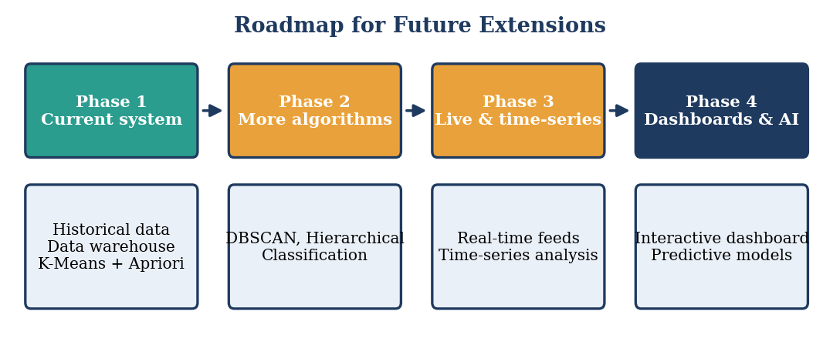
Figure 19: Proposed roadmap for the future extension of MarketMiner
.
- CONCLUSION

The project “MarketMiner: Stock Trend Clustering and Pattern Mining” demonstrates the practical application of Data Warehousing and Data Mining techniques to historical stock market data.
The system provides a structured approach for collecting, cleaning, transforming and storing stock information in a data warehouse. The stored data can then be analyzed using data mining techniques.
Clustering is used to group stocks with similar historical characteristics, while pattern mining is used to identify frequently occurring combinations and relationships.
Through this project, practical knowledge of ETL, data preprocessing, dimensional data organization, clustering, pattern mining and visualization is gained.
MarketMiner provides an effective academic framework for exploring stock market datasets and extracting useful information from them. However, the discovered patterns are based on historical data and should not be considered guaranteed predictions of future stock prices.
Overall, the project successfully demonstrates how Data Warehousing and Data Mining can transform large volumes of raw stock data into structured and meaningful analytical information.
The work done in this project shows that a systematic pipeline is more effective than manual inspection when large volumes of stock data have to be studied. The ETL stage ensured that the data was reliable, the star schema ensured that it was well organised, and the mining stage produced clusters and rules that could be described in simple terms.
The use of K-Means helped to divide the stocks into groups such as high-growth, stable and high-volatility, and the examination of cluster profiles gave meaning to these groups. The use of Apriori demonstrated how numerical behaviour can be converted into categories and how frequent combinations such as high volume together with positive return can be identified and measured with support, confidence and lift.
From a learning point of view, the project gave practical exposure to the tools of the data science ecosystem, namely Python, Pandas, NumPy, Scikit-learn, MLxtend, a relational database and plotting libraries. It also showed the importance of preprocessing, scaling and parameter selection, since the quality of every later result depends on these early decisions.
The project has some limitations. It works on historical data only, the clusters depend on the chosen features and on the value of K, and the rules depend on the chosen thresholds. These limitations can be reduced in future work by using more data, testing other algorithms and validating the results on new periods. Even so, MarketMiner meets its objective of demonstrating how Data Warehousing and Data Mining can be used together for meaningful analysis.
In summary, the project has achieved its aim of combining the storage and organisation strengths of a data warehouse with the discovery strengths of data mining. The report as a whole describes the problem, the study that preceded the work, the tools and hardware that were used, the stages of the implemented system, the form of the results, and the benefits and applications of the approach, and thus provides a complete academic record of the MarketMiner project.

RESEARCH & REFERENCES

9.1 Research
The project was developed after studying concepts related to:
- Data Warehousing
- ETL processes
- Dimensional modeling
- Data preprocessing
- Data mining
- K-Means clustering
- Association rule mining
- Apriori algorithm
- Stock market data analysis
- Data visualization
The study began with the basic concepts of data warehousing, namely the difference between operational and analytical systems, the characteristics of a warehouse (subject-oriented, integrated, time-variant and non-volatile) and the design of fact and dimension tables. It continued with the data mining techniques that are relevant to the project, namely preprocessing, clustering and association rule mining.
The documentation of the Python libraries was then studied to understand how the algorithms are implemented and how their parameters influence the output. Particular attention was given to the preparation of data for K-Means (scaling and the selection of K) and to the transaction format needed for Apriori.
Lastly, the structure of stock market data was studied so that the right fields could be selected, the right derived measures could be calculated and the results could be interpreted with care. This study made it clear that discovered patterns describe the past and should be presented as analytical findings and not as predictions.

9.2 References
- Jiawei Han, Micheline Kamber and Jian Pei — Data Mining: Concepts and Techniques
- Ralph Kimball and Margy Ross — The Data Warehouse Toolkit
- Python Documentation
- Pandas Documentation
- NumPy Documentation
- Scikit-learn Documentation
- Matplotlib Documentation
- Research papers and educational resources related to stock market data mining
- Educational resources related to K-Means clustering and association rule mining
- Educational resources related to Data Warehousing and ETL
- Rakesh Agrawal and Ramakrishnan Srikant — Fast Algorithms for Mining Association Rules, Proceedings of the 20th International Conference on Very Large Data Bases (VLDB), 1994
- J. MacQueen — Some Methods for Classification and Analysis of Multivariate Observations, Proceedings of the Fifth Berkeley Symposium on Mathematical Statistics and Probability, 1967
- David Arthur and Sergei Vassilvitskii — k-means++: The Advantages of Careful Seeding, ACM-SIAM Symposium on Discrete Algorithms (SODA), 2007
- Peter J. Rousseeuw — Silhouettes: A Graphical Aid to the Interpretation and Validation of Cluster Analysis, Journal of Computational and Applied Mathematics, Vol. 20, 1987
- William H. Inmon — Building the Data Warehouse, John Wiley & Sons
- F. Pedregosa et al. — Scikit-learn: Machine Learning in Python, Journal of Machine Learning Research, Vol. 12, 2011
- Wes McKinney — Data Structures for Statistical Computing in Python, Proceedings of the 9th Python in Science Conference, 2010
- C. R. Harris et al. — Array Programming with NumPy, Nature, Vol. 585, 2020
- J. D. Hunter — Matplotlib: A 2D Graphics Environment, Computing in Science & Engineering, Vol. 9, No. 3, 2007
- Sebastian Raschka — MLxtend: Providing Machine Learning and Data Science Utilities and Extensions to Python's Scientific Computing Stack, Journal of Open Source Software, Vol. 3, No. 24, 2018
This structure deliberately follows the same progression and academic style as your uploaded report, while expanding the implementation section around the actual Data Warehousing/Data Mining workflow. The original report's structure moves from introduction and literature study into hardware/software, implementation, results, advantages/disadvantages, applications, conclusion, and references, which I've preserved here.

